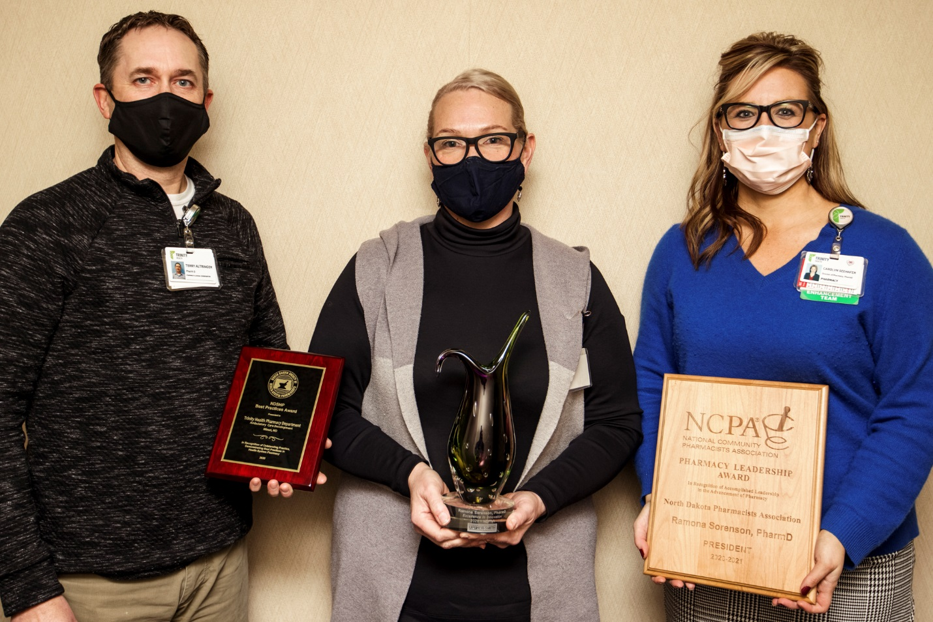

Trinity Health Receives Pharmacy-Related Accolades

Ramona Sorenson, PharmD and the Trinity Health Ambulatory Care Pharmacy Practice recently received recognition for their work on making valuable contributions towards the advancement of patient care in the practice of pharmacy.
The Trinity Health Ambulatory Care Pharmacy Practice received the Best Practice in Ambulatory Care Development award from the North Dakota Society of Health System Pharmacists.
Sorenson received the Excellence in Innovation award from the North Dakota Pharmacists Association (NCPA).
Pictured with Sorenson, center, are Terry Altringer, Pharmacy Clinical Services Supervisor, and Carolyn Seehafer, Pharmacy Director with Trinity Health.

